Kazakh-British Technical University
Data collection and preparation

Laboratory work №1

Reading and Converting Formats

Full Name: Baibolov Sultanmakhmut
ID: 23B031235

08.09.2026
Almaty

Table of contents
Task 1. Dataset selection 3
Task 2. Data-quality analysis 5
Task 3. Data formats 4
Task 4. Data format comparison 4

Task 1. Dataset selection
Select an open dataset from Kaggle, Data.gov, World Bank Open Data, UN Data or another open source. The dataset must contain at least 100 rows, five columns and at least one data-quality problem.

- Dataset name and source link
Dataset name - Netflix Movies and Series
Source link - https://www.kaggle.com/datasets/debayank2024/netflix-movies-and-series?resource=download

- Author
Author - Debayan Bandyopadhyay (https://www.kaggle.com/debayank2024)

- Number of rows and columns
Rows – 8807
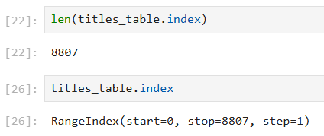
Columns - 12
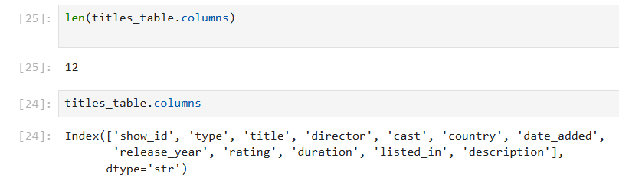
- Meaning of 1 row and each column
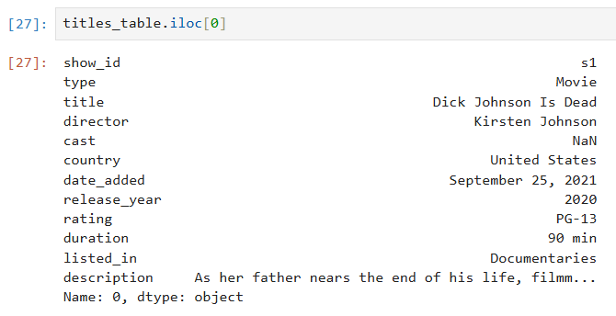
- show_id –title id,
- type –title type (Movie/TV Show),
- title –name of the title,
- director –directors separated by commas (NaN if unknown),
- cast – list of actors separated by commas,
- country – production country,
- date_added – the Netflix adding date,
- release_year – release year,
- rating – content rating (https://en.wikipedia.org/wiki/Content_rating),
- duration – duration of the title (“X min” for movies and “X Seasons” for TV Shows),
- listed_in – title genres and tags (e. g. Dramas, International Movies),
- description – title description.

- Dataset type
Structured

Task 2. Data-quality analysis
Identify the data types, missing values, duplicates, invalid values, inconsistent categories, incorrect date or number formats, and possible outliers. Present the results in a table containing the column name, identified problem, example, and its possible effect on further data analysis.

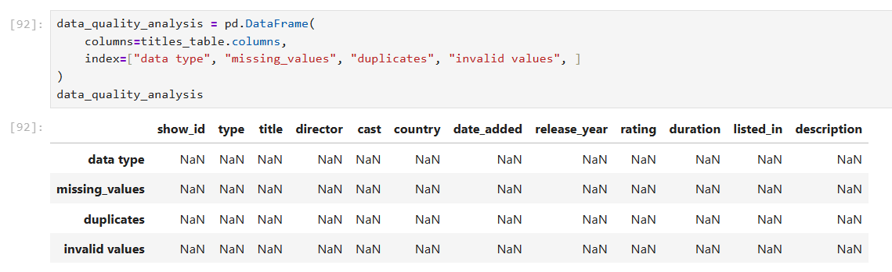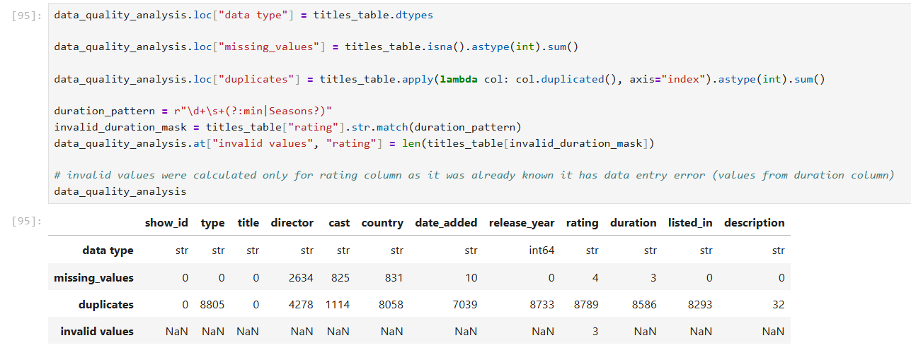
Feather format reading and writing is much faster than csv, also ocupying less storage.

Column name | Identified problem | Example | Possible effect on further data analysis
date_added | Data type is str, string representation is unusual | “September 25, 2021” | Incorrect sorting, validation errors, broken date manipulation
rating | Data entry error | “74 min” | Validation error, data inconsistency
director, cast, country, date_added, rating, duration | Missing values | s5541: duration - NaN | Bias, reduced statistical power

Data problems analysis table

Task 3. Data formats
Save the prepared dataset in one suitable format and one alternative format. Compare CSV, JSON, Parquet, ORC, and Avro according to their representation, storage structure, schema support, human readability, typical applications, advantages, and limitations. Present the comparison to a table. Explain which format is the most appropriate for the selected dataset and justify your choice.

I chose the feather (Arrow IPC) format for fast file writing and reading to clearly demonstrate the difference between it and the csv format. The original dataset was in csv format, which I used to read the data. Also, the dataset is small and requires only one file reading operation, while all data analysis is done by the code, which makes it most suitable in my opinion.

File format / Criteria | CSV | JSON | Parquet | ORC | Avro
Representation | Comma separated values | Hierarchical list of JS objects | Columnar chunks with footer metadata | Columnar stripes with internal indexes | Binary row-based JSON records
Storage structure | Row-based | Hierarchical | Columnar | Columnar | Row-based
Schema support | No | No | Yes | Yes | Yes
Human readability | Yes | Yes | Yes | No | No
Typical applications | Data sharing between teams and loading to Excel table | Data exchange between apps via HTTP | Storing large amount of compressed data | Enterprise data processing | Real-time event streaming
Advantages | Universal, low write overhead | Human readable, flexible | Compression, fast queries | Compression, indexing | Compact, ultra-fast writes
Limitations | No schema, poor performance | High redundancy, slow parsing | Slow write, not human readable | Edit restrictions, slow write | Poor read, schema dependency

Task 4. Data format comparison
For the two formats used in your practical work, measure and compare file size, writing time, reading time, preservation of rows and columns, data types, and missing values.

